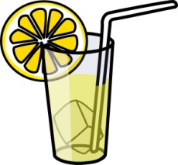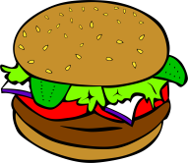
A Science Menu
Appetizer (Everyone Shares)
Write the chemical equation for photosynthesis.
Entrée (Select One)
Draw a picture that shows what happens during photosynthesis.
Write two paragraphs about what happens during photosynthesis.
Create a rap that explains what happens during photosynthesis.
Side Dishes (Select at Least Two)
Define respiration, in writing.
Compare photosynthesis to respiration using a Venn diagram.
Write a journal entry from the point of view of a green plant.
With a partner, create and perform a skit that shows the differences between photosynthesis and respiration.
Dessert (Optional)
Create a test to assess the teacher’s knowledge of photosynthesis.

